**In preparation for live session, please complete the following. Be sure and submit your work to the "Unit 1: "For Live Session" Assignment" assignment on 2DS:**

1. For live session, find an example of time-series data. We will work with this data set throughout this lesson. For now simply find a data set and make sure it is in CSV format. (You may need to work at this a bit.)  
     
   Write a brief one- to three-sentence description in the Google Doc provided by your instructor.
2. In your data set, identify  x1 , x2 , x3, and add it to your Google Doc entry under the description.  
   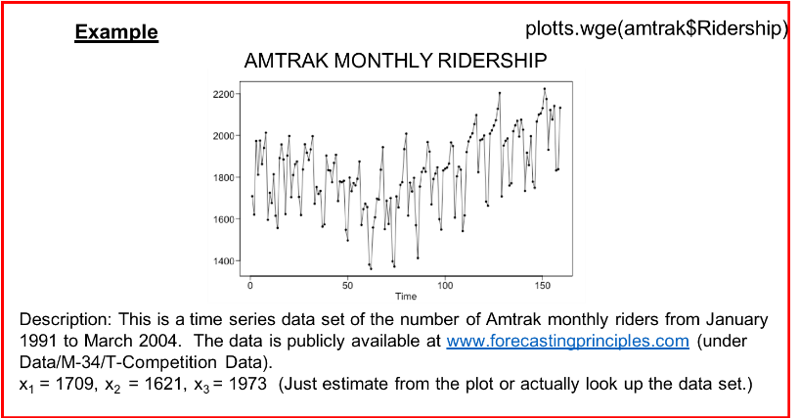
3. Using your time series that you selected, would you be able to obtain another realization? Discuss in one or two sentences, and add it to the Google Doc.
4. With respect to your time series, does it appear that the assumption of constant mean of the distribution of each Xt is reasonable?  Discuss why or why not in one or two sentences, and place on the Google Doc.
5. With respect to your time series, does it appear that the assumption of constant variance of the distribution of each Xt is reasonable?  Discuss why or why not in one or two sentences, and place on the Google Doc.
6. Provide the ACF for your time series. Is your time series stationary? Discuss in a few sentences on the Google Doc.

**Upon completing the above, please write a brief reflection of your thoughts and key takeaways and submit a single slide PowerPoint of that reflection via the online campus.**